Product Requirements Document
Project Name: FUNewsTradingSystem (Automated Trading Agents by News)
Document Version: 1.0
Target Framework: ASP.NET Core MVC (.NET 5/6/7/8)
Architecture: 3-Layer Architecture (MVC, Service, Repository)

1. Project Overview & Objectives

1.1. Introduction
A FUNewsTradingSystem (FNTS) is a software application that helps financial institutions and educational organizations efficiently manage market news and automatically analyze stock trends. By applying AI-driven analysis, the system processes current news to predict whether a stock should be Bought, Sold, or Held. By integrating external News APIs and Large Language Model (LLM) APIs, the system automatically aggregates real-time market news, processes it through a simulated pipeline of AI financial analysts (Sentiment Agent, Fundamental Agent, and Portfolio Manager), and generates actionable trading reports (Buy/Sell/Hold decisions).

1.2. Core Objectives
- Build a robust ASP.NET Core Web App (MVC) utilizing Entity Framework Core.
- Strictly implement a 3-Layer architecture (Presentation, Business Logic/Service, Data Access/Repository) and the Singleton pattern.
- Automate the creation of "News Articles" by implementing an asynchronous AI pipeline that fetches news and generates financial predictions without manual typing.
- Provide distinct functionalities based on User Roles (Admin, Staff, Lecturer, Guest).

2. Target Audience & User Roles
The system supports role-based access control (RBAC). The default Admin credentials (admin@FUNewsTradingSystem.org / @@abc123@@) are stored securely in appsettings.json.
Role | Description & Permissions
Guest | Unauthenticated users. Can view active Trading Analysis Reports (news status = active) and AI predictions.
Lecturer (Investor) | Authenticated users (Role = 2). Can view active Trading Analysis Reports and read the detailed AI insights.
Staff (System Operator) | Authenticated users (Role = 1). Responsible for managing market sectors (Categories), stock tickers (Tags), and triggering the Automated AI Trading Pipeline. Can view their generated report history and manage their profile.
Admin | System administrator. Manages all accounts and generates statistical reports (e.g., reports created within a specific Date Range, sorted descending).

3. Database Design & Entity Mapping
The database (FUNewsManagement) schema is repurposed to fit the financial trading context while maintaining the original structural requirements.
- SystemAccount
  - Purpose: Stores credentials and role definitions for all users within the system (Admin, Staff/Operator, Lecturer/Investor).
  - AccountID (Primary Key): Unique identifier for the account.
  - AccountName: Full name of the user.
  - AccountEmail: User's login email (e.g., admin@FUNewsTradingSystem.org).
  - AccountRole: Integer representing access level (1 = Staff/Operator, 2 = Lecturer/Investor, 3 = Admin).
  - AccountPassword: Securely stored password for authentication.
- Category
  - Purpose: Represents broader Market Sectors or Asset Classes (e.g., Technology, Healthcare, Cryptocurrencies).
  - CategoryID (Primary Key): Unique identifier for the sector.
  - CategoryName: Name of the market sector.
  - CategoryDescription: Brief overview of the sector's characteristics.
  - ParentCategoryID: Self-referencing foreign key to allow hierarchical sectors (e.g., "AI Hardware" under "Technology").
  - IsActive: Boolean flag to enable or disable reporting for this sector.
- Tag
  - Purpose: Represents specific Stock Tickers or Financial Instruments (e.g., AAPL, NVDA, SPY).
  - TagID (Primary Key): Unique identifier for the ticker.
  - TagName: The actual ticker symbol or company name.
  - Note: Additional metadata about the ticker (e.g., "High volatility tech stock").
- NewsArticle
  - Purpose: Serves as the automated "Trading Analysis Report" generated by the AI agents.
  - NewsArticleID (Primary Key): Unique identifier for the report.
  - NewsTitle: Auto-generated title indicating the final AI decision (e.g., "[BUY] NVDA Automated Analysis").
  - Headline: A short, one-sentence summary of the AI's core reasoning (e.g., "Strong fundamental growth outweighs short-term sentiment risks.").
  - CreatedDate: Timestamp of when the pipeline executed.
  - NewsContent: The detailed, structured output from the LLM (containing Fundamental view, Sentiment view, and Risk warnings).
  - NewsSource: Stores metadata about the data origin (e.g., "Data fetched via Yahoo Finance API; Analyzed by GPT-4").
  - CategoryID (Foreign Key): Links the report to its respective Market Sector.
  - NewsStatus: Boolean/Integer flag indicating if the report is active and visible to guests/investors.
  - CreatedByID (Foreign Key): Links to the SystemAccount of the Staff member who triggered the AI pipeline.
  - UpdatedByID (Foreign Key): Links to the SystemAccount of the Staff member who last modified or archived the report.
  - ModifiedDate: Timestamp of the last update.
- NewsTag
  - Purpose: A junction table that links a Trading Analysis Report to the specific Stock Tickers it analyzes.
  - NewsArticleID (Primary Key, Foreign Key): Identifier of the report.
  - TagID (Primary Key, Foreign Key): Identifier of the ticker.
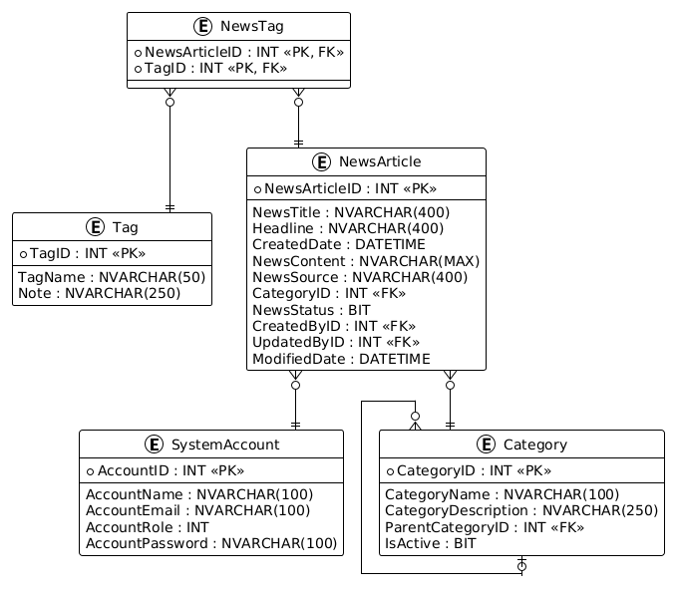

4. Functional Requirements

4.1. Authentication & Authorization
- FR-1.1: The default UI upon launching the application must be the Login window.
- FR-1.2: Users must authenticate using Email and Password.
- FR-1.3: The system must restrict controller actions based on user roles using authorization filters or middleware.

4.2. Automated Trading Agent Pipeline (Core Feature)
- FR-2.1: Trigger Analysis: Staff selects a Ticker (Tag) and a Sector (Category), then clicks "Run Analysis".
- FR-2.2: Data Fetching: The system's Service Layer asynchronously calls an external News API to fetch the latest headlines for the selected Ticker.
- FR-2.3: Multi-Agent LLM Orchestration: The Service Layer sends the fetched data to an LLM API (e.g., OpenAI, Gemini) through a sequence of specific prompts:
  - Step 1 (Sentiment Agent): Evaluates market mood based on headlines.
  - Step 2 (Fundamental Agent): Evaluates core business impact.
  - Step 3 (Portfolio Manager): Synthesizes previous steps to output a final decision (BUY, SELL, or HOLD) in JSON format.
- FR-2.4: Auto-Save: The system parses the JSON response and automatically inserts a new NewsArticle record into the database.

4.3. Entity Management (CRUD Operations)
- FR-3.1: Account Management: Admin can Read, Create, Update, and Delete system accounts.
- FR-3.2: Category Management: Staff can Read, Create, Update, and Delete categories. Deletion is only permitted if the category is not linked to any existing reports.
- FR-3.3: Tag Management: Staff can manage tags representing stock tickers.
- FR-3.4: UI Constraints:
  - Create and Update actions must be performed via popup dialogs (modals).
  - Delete actions must include a confirmation prompt.
  - Data type validation must be applied to all input fields.

4.4. Reporting & Analytics
- FR-4.1: Admin can generate a statistical report filtering generated AI articles by a period (StartDate to EndDate based on created date).
- FR-4.2: The statistical report data must be sorted in descending order.

5. Non-Functional Requirements

5.1. System Architecture
- Controllers must not connect directly to the database. All data operations must flow through: Controller -> Service -> Repository -> Data Access Object (DAO) / DbContext.
- The LLM API and News API integrations must be encapsulated within dedicated Service classes (e.g., TradingAgentService).

5.2. Configuration & Security
- Database connection strings, Admin credentials, and API Keys (News API, LLM API) must be stored securely in the appsettings.json file.
- The project solution must be named StudentName_ClassCode_A01.sln, containing the web project named StudentNameMVC.

5.3. Performance & Reliability
- All external API calls (News fetching, LLM prompting) must utilize asynchronous programming (async/await and HttpClient) to prevent blocking the main thread.
- The system must handle API timeouts gracefully and inform the Staff if the AI pipeline fails to generate a report.

6. Out of Scope
- Actual Trade Execution: The system is an analytical simulation. It will not connect to real brokerage accounts to execute financial transactions.
- Real-time WebSocket Streaming: Data is fetched on-demand when triggered by Staff, rather than streaming live market ticks.

